1.練習啟動和停止各種Kali服務

systemctl start ssh

sudo ss -antlp | grep sshd

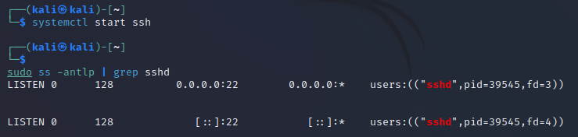

systemctl stop ssh

sudo ss -antlp | grep sshd

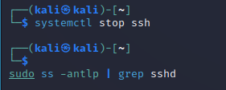

2.在系統開機時啟用SSH服務

sudo systemctl enable ssh

